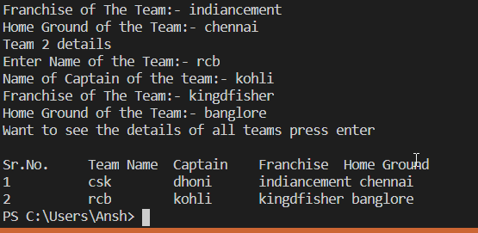

Code Written in Python 3 using VS Studio:-

1. Use the concept of Dictionary and list to store the details of all the teams.
2. Format printing is used for printing the result in the desired format